**Semester Review**

**Do the indicated operation and write your answers in simplest form.**

1) 2 + 1  = 2)  • 3 = 3) 9 − 7 =

4) 1 ÷ 3 = 5) -  - (-) = 6) 5 - 7 =

7) -  •  = 8) -1 • (- ) = 9) -4 + 3 =

10) 6 + 3 = 11) 3 ÷ 1 = 12) 4 ÷ (-1) =

**Write an algebraic expression for each of the following.**

|  |  |  |
| --- | --- | --- |
| 13. | The sum of ***x*** and two |  |
| 14. | The difference when five is subtracted from ***t*** |  |
| 15. | *x* is added to 15 |  |

**Perform the indicated operation.**

16) –1 + 10 = 17) -14 – 23 = 18) -9(-7) = 19) -49 ÷ 7 =

**Given that *a = -6, b = 2,* evaluate the following.**

20) a − b 21)  22) b(-a)

**Fill in the blanks with >, <, or =.**

23) |-8| _____ 8 24) |15 − 16| _____ |16 - 15| 25) |-11| _____ |11|

**Solve the following equations showing all work**.

26) x – 5 = 7 27) 22 = x + 13 28) 2x = 42 29)  = 143

**Simplify.**

30) 31)

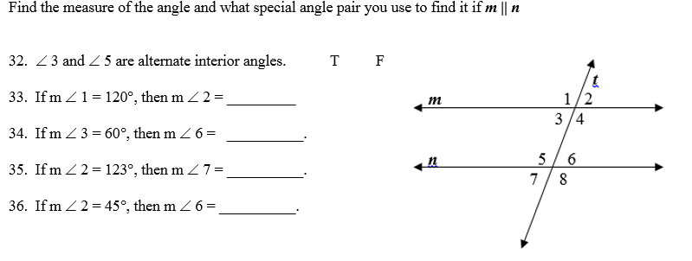

**Solve the equation.**

37) 38)

39) 40)

**Simplify showing all steps**.

41)  + (2 − 14) 42) 7 − 6[5 + 4(3 − 1)]

43) 80 − 3(8 + 7) 44) 18 + 3 − (-12 + 7)

Find the decimal equivalent for each of the following fractions.

45)  = 46)  = 47)  = 48)  =

Find the fractional equivalent for each of the following decimals. Use place value!

49) 0. = 50) –2.75 = 51) 7. = 52) 0.486 =

Know the names of all polygons with sides from 3 – 10. Find the interior angle sum, one interior angle, and one exterior angle of a regular hexagon.

53) interior angle sum 54) one interior angle 55) one exterior angle

56) Find the volume of a cylinder base radius of 8 feet and height of 7 feet.

58) Find the volume of a cone with diameter of 20 meters and height of 16 meters.

59) Find the volume of a sphere with radius of 6 cm.