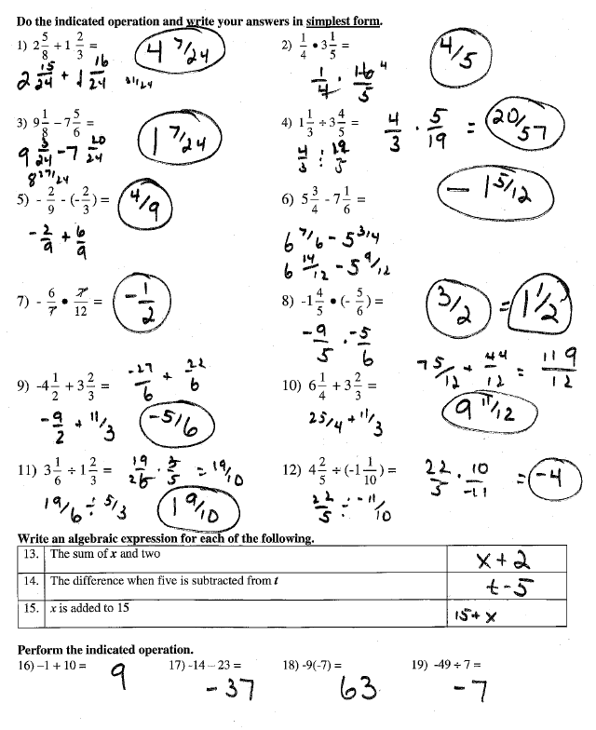
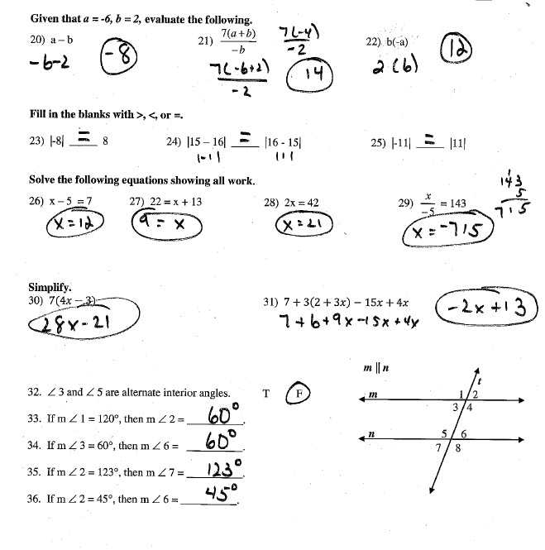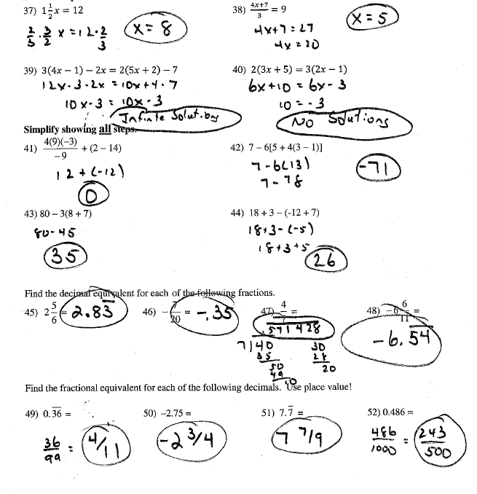
Regular hexagon
53) interior angle sum 54) one interior angle 55) one exterior angle
720° 120° 60°
56) Find the volume of a cylinder base radius of 8 feet and height of 7 feet. 1406.7 ft³
58) Find the volume of a cone with diameter of 20 meters and height of 16 meters. 1674.7 m³
59) Find the volume of a sphere with radius of 6 cm. 904.3 cm³

