Pre Algebra LT 1.1 Reassessment Name ______________________

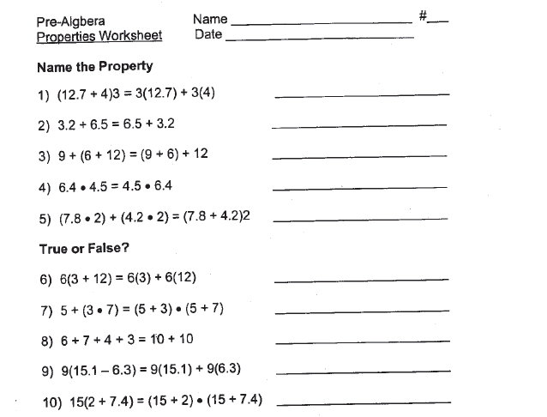
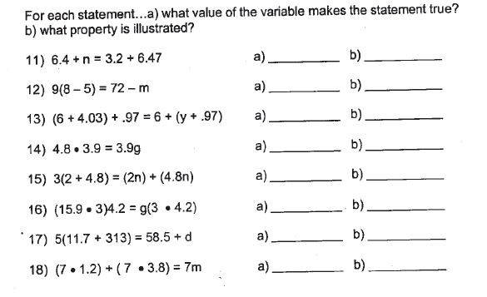
Pre Algebra LT 1.2 Reassessment Name ______________________

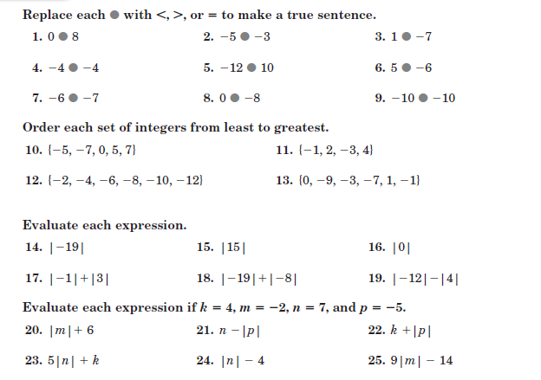

Pre Algebra LT 1.3 Reassessment Name ______________________

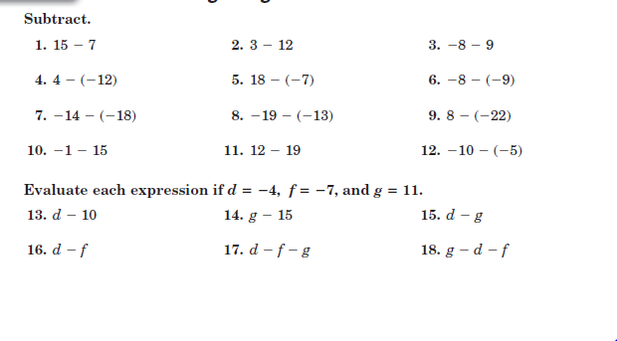

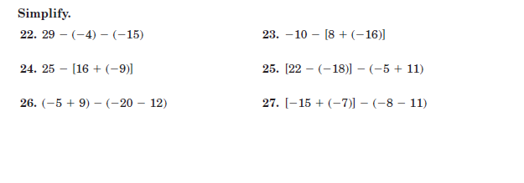

Pre Algebra LT 1.4 Reassessment Name ______________________

