Pre-Algebra LT 2.1 Reassessment Name _____________________________

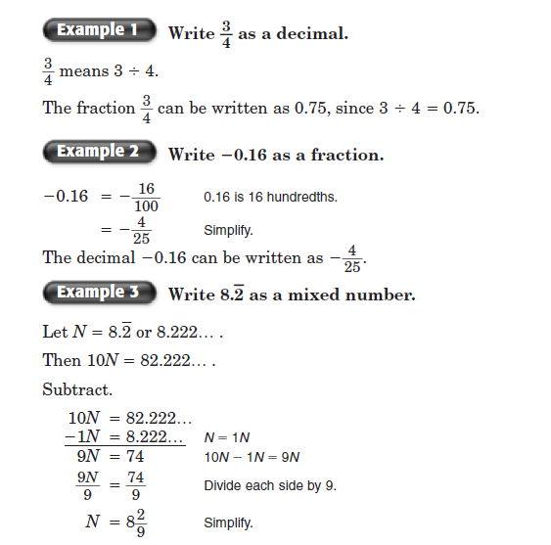
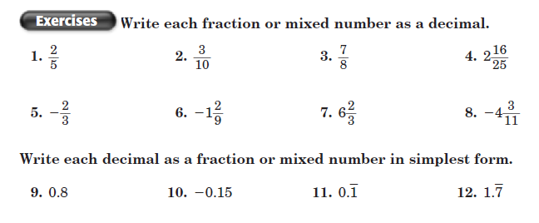

Pre-Algebra LT 2.2 Reassessment Name _____________________________

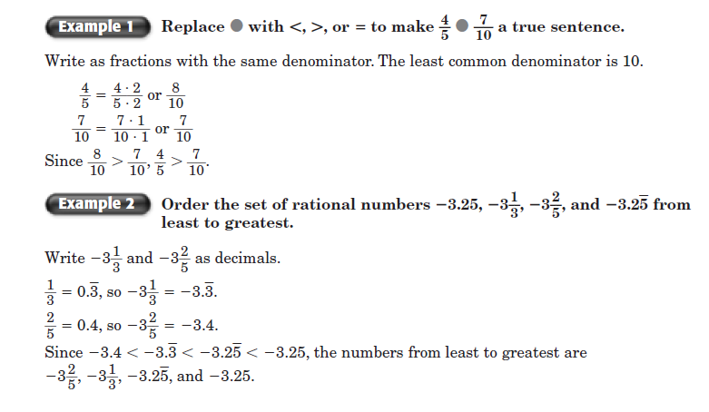
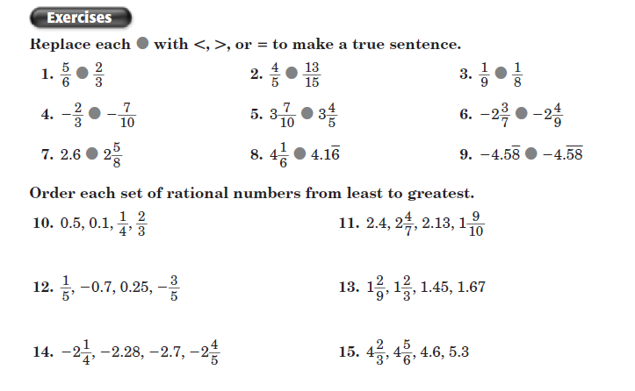
Pre-Algebra LT 2.3 Reassessment Name _____________________________

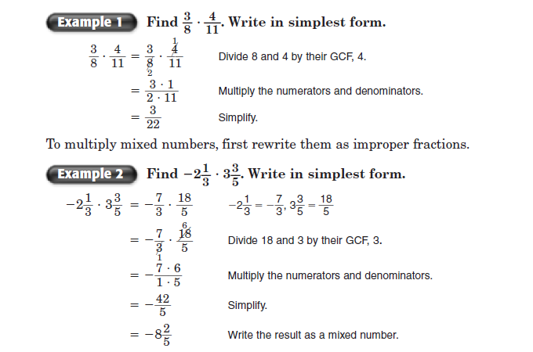
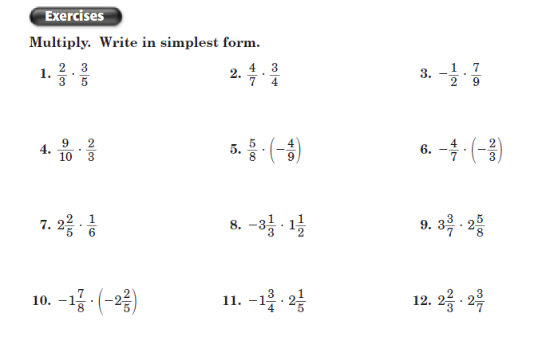

Pre-Algebra LT 2.4 Reassessment Name _____________________________
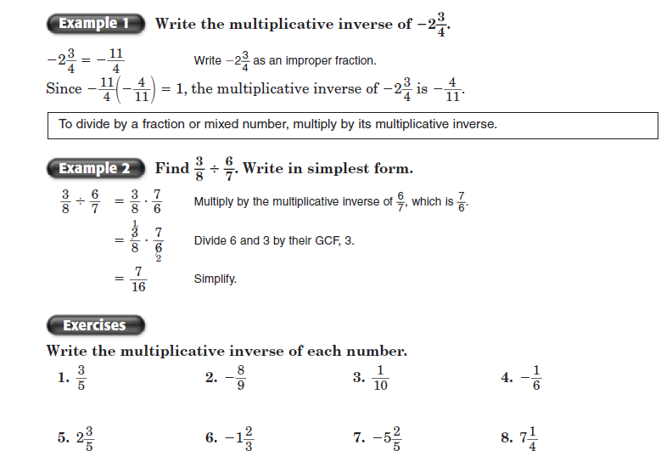
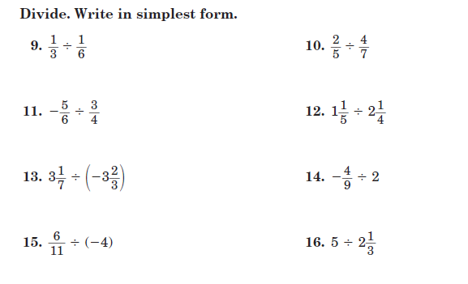

Pre-Algebra LT 2.5 Reassessment Name _____________________________
