LT 3.1 Reassessment WS Name _________________

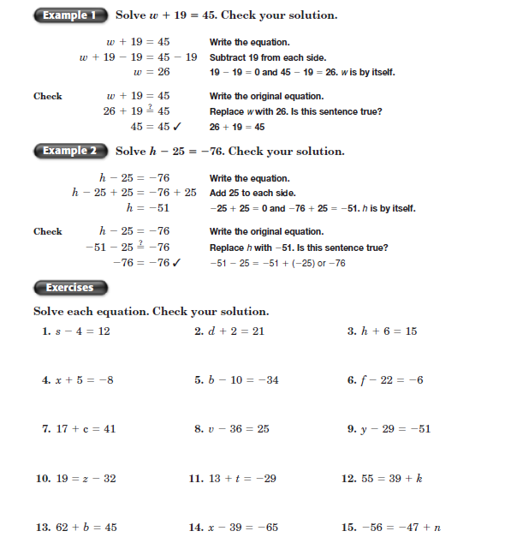

LT 3.2 Reassessment WS Name _________________

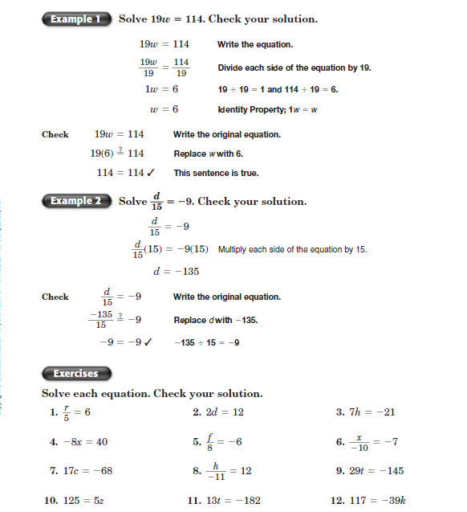

LT 3.3 Reassessment WS Name _________________

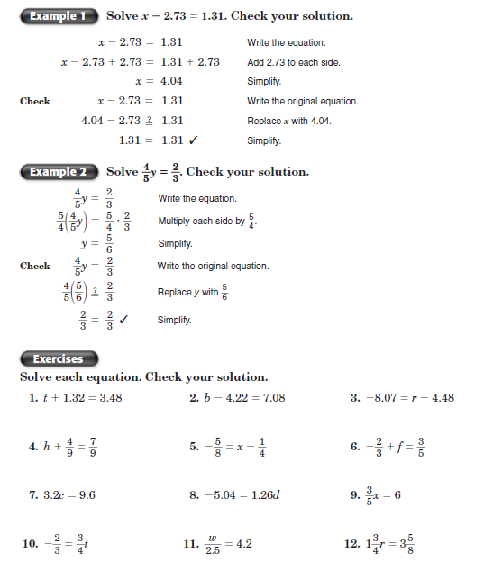

LT 3.4 Reassessment WS Name _________________

