LT 4.1 Reassessment WS Name _________________

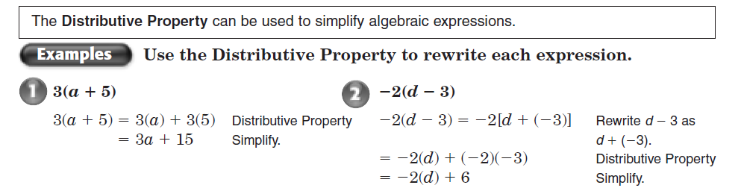

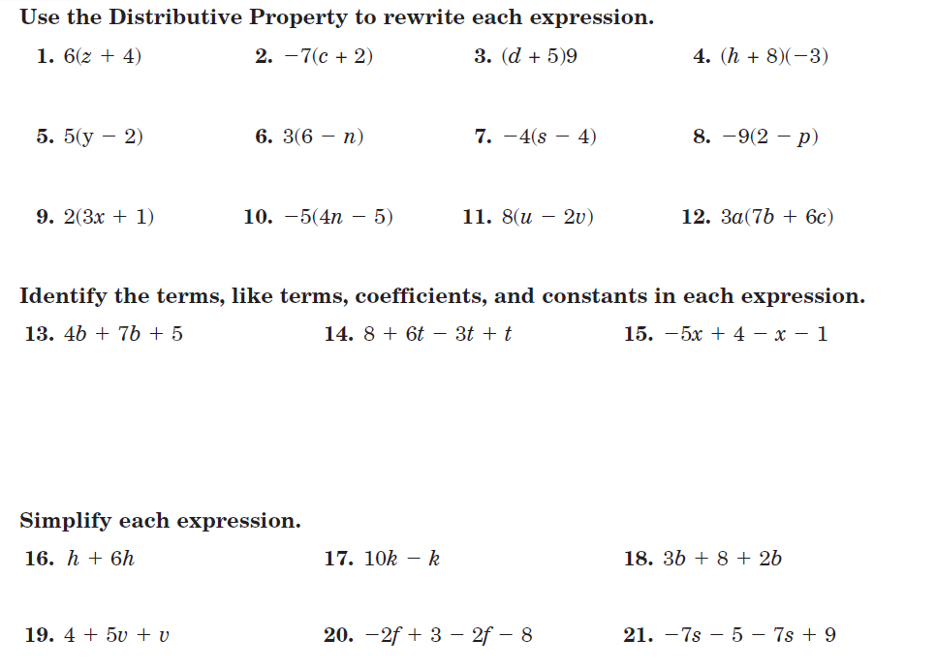

LT 4.2 Reassessment WS Name _________________

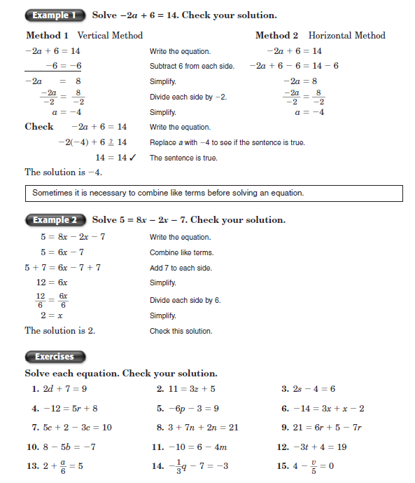

LT 4.3 Reassessment WS Name _________________

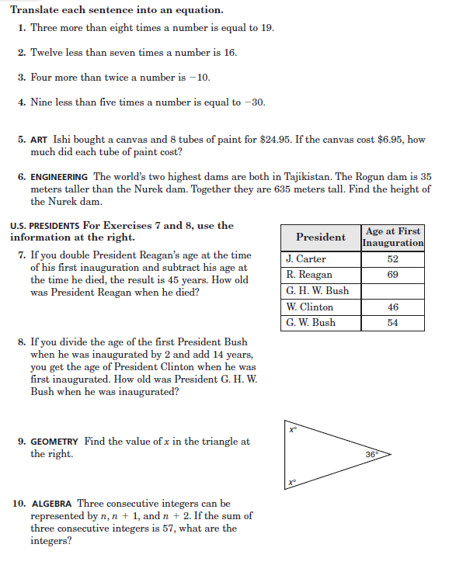

LT 4.4 Reassessment WS Name _________________
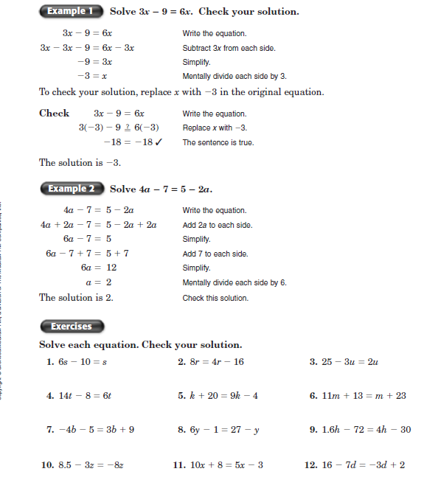

LT 4.5 Reassessment WS Name _________________

