Pre-Algebra WS 6.1 A/B Name ________________________
6.1 A I can find the circumference of a circle. 6.1 B I can find the area of a circle.
Use 3.14 for $π$ and round your answer to the nearest tenth.
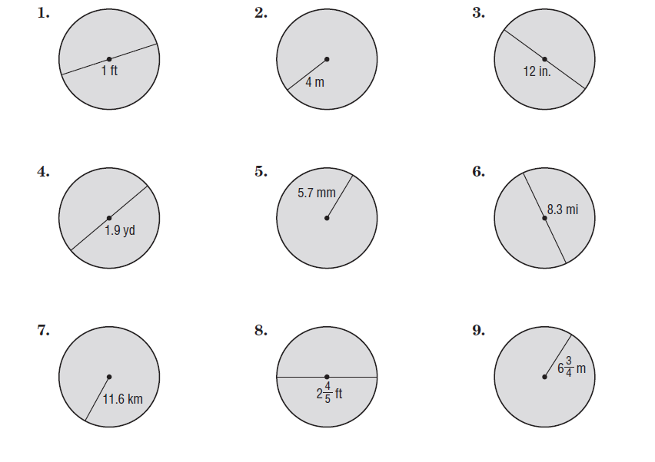
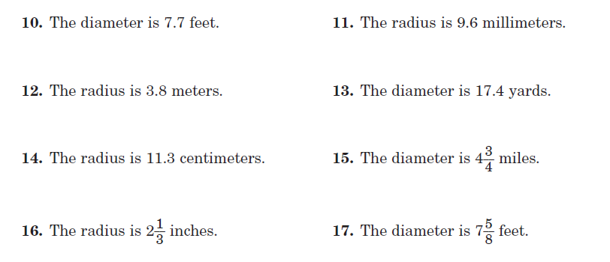
18. Find the radius if the circumference of a circle is 56.52 cm.
19. Find the diameter if the circumference of a circle is 62.8 ft.
20. Find the radius if the area of a circle is 28.26 cm².
21. Find the diameter if the area of a circle is 63.585 ft².

6.2 I can find the volume of a cylinder Name ________________________
Find the Volume of the following. Use 3.14 for $π$ and round your answer to the nearest tenth.

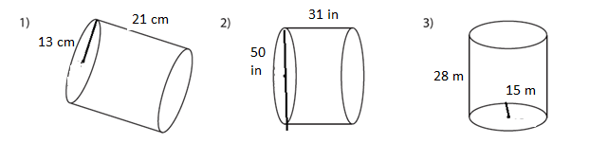

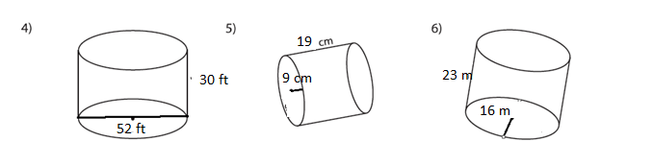

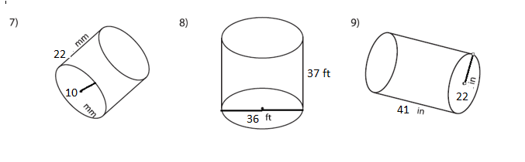
10. Find the radius if the amount of wax required to make a candle with a height of 61 mm and volume of 1723.86 mm³.

11. Find the height if the amount of wax required to make a candle with a radius of 11 cm and volume of 2659.58 cm³.

6.3 I can find the volume of a cone Name ________________________
Find the Volume of the following. Use 3.14 for $π$ and round your answer to the nearest hundredths.

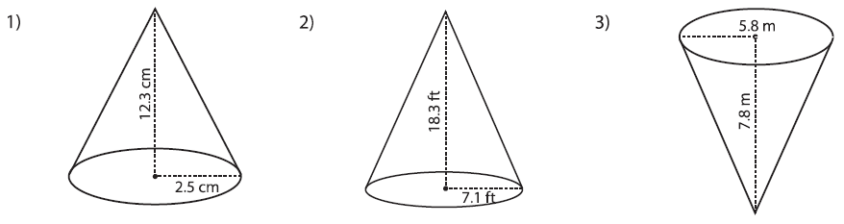

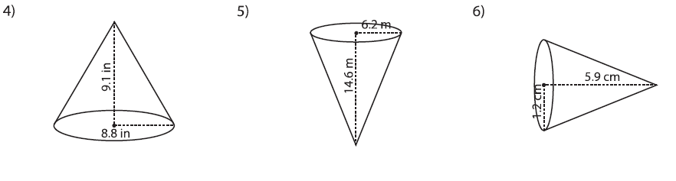

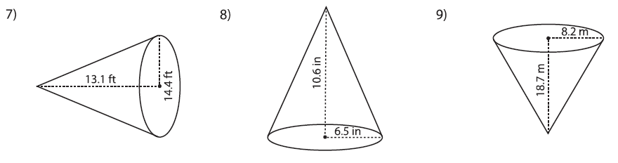

10. Find the radius of a cone if the volume is 150.72 ft³ and the height is 9 ft.

11. Find the height of a cone if the volume is 65.94 cm³ and the radius is 3 cm.
6.4 I can find the volume of a sphere Name ________________________
Find the Volume of the following. Use 3.14 for $π$ and round your answer to the nearest hundredths.
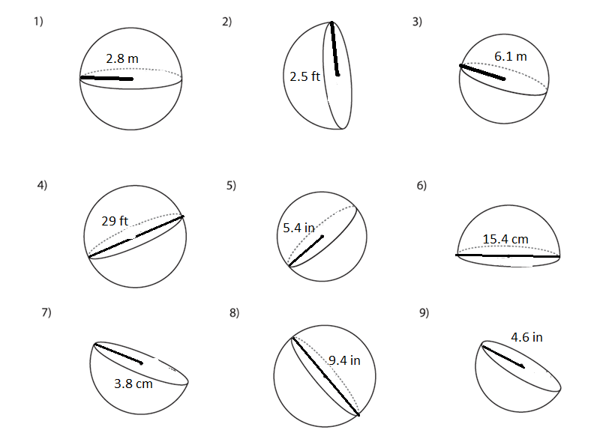

10. Find the radius of a sphere if the volume is 33.49$\overline{3}$ ft³.

11. Find the radius of a sphere if the volume is 523.$\overline{3}$ cm³.

